**Sorting Algorithms:**

A Sorting Algorithm is used to rearrange a given array or list of elements according to a comparison operator on the elements. The comparison operator is used to decide the new order of elements in the respective data structure.

For Example: The below list of characters is sorted in increasing order of their ASCII values. That is, the character with a lesser ASCII value will be placed first than the character with a higher ASCII value.

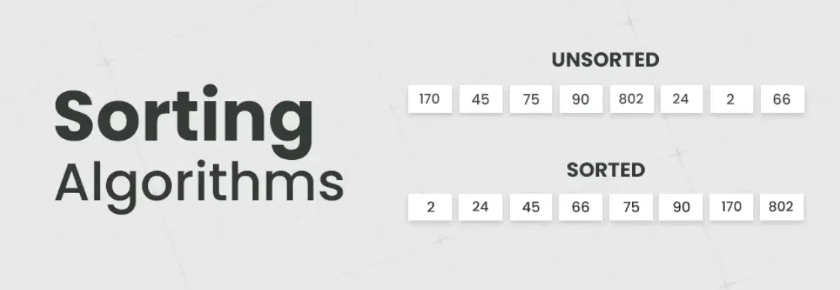

**What is Sorting?**

Sorting refers to rearrangement of a given array or list of elements according to a comparison operator on the elements. The comparison operator is used to decide the new order of elements in the respective data structure. Sorting means reordering of all the elements either in ascending or in descending order.

**Applications of Sorting Algorithms:**

**Searching Algorithms:** Sorting is often a crucial step in search algorithms like binary search and Ternary Search. A lot of Greedy Algorithms use sorting as a first step to apply Greedy Approach. For example Activity Selection, Fractional Knapsack, Weighted Job Scheduling, etc

**Data management:** Sorting data makes it easier to search, retrieve, and analyze. For example the order by operation in SQL queries requires sorting.

**Database optimization:** Sorting data in databases improves query performance. We preprocess the data by sorting so that efficient searching can be applied.

**Machine learning:** Sorting is used to prepare data for training machine learning models.

**Data Analysis:** Sorting helps in identifying patterns, trends, and outliers in datasets. It plays a vital role in statistical analysis, financial modeling, and other data-driven fields.

**Operating Systems:** Sorting algorithms are used in operating systems for tasks like task scheduling, memory management, and file system organization.

**[Bubble Sort](https://www.geeksforgeeks.org/bubble-sort/) :**There are many sorting algorithms. We will understand and apply bubble short algorithm in this practical. The bubble sort algorithm might look a little bit confusing when we first study it. But here is the easy explanation of it. Here swapping is carried on in two ways. In every iteration of the outer loop, the largest element is found and swapped with the last element in the loop. In the inner loop, we do pairwise swapping of two consecutive elements. In every inner loop, we go from the first element to the one less element we went in the previous loop. The image below shows the 1st iteration of the inner loop in the Bubble Sort Algorithm.

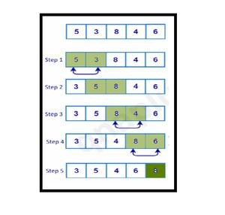

Here we can simplify the bubble sort algorithm by saying that the sorting here is done on the basis of the largest to the smallest element. The largest element is first kept in the last location in the array. Then the second largest element in the second last location as so on**.**

**Write a program in 8086 microprocessor to sort numbers in ascending order in an array of n numbers, where size “n” is stored at memory address 0100 : 500 and the numbers are stored from memory address 0100 : 501.**

**Example –**

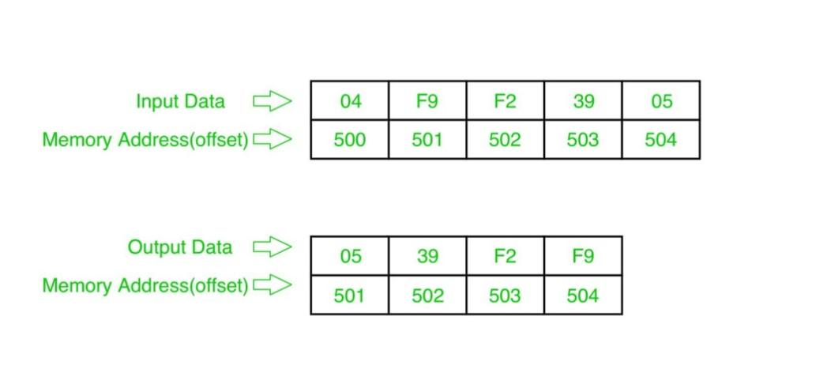

**Example explanation:**

Pass-1:

F9 F2 39 05

F2 F9 39 05

F2 39 F9 05

F2 39 05 F9 (1 number got fix)

Pass-2:

F2 39 05 F9

39 F2 05 F9

39 05 F2 F9 (2 number got fix)

Pass-3:

39 05 F2 F9

05 39 F2 F9 (sorted)

**Algorithm –**

1. Load data from offset 500 to register CL (for count).
2. Travel from starting memory location to last and compare two numbers if first number is greater than second number then swap them.
3. First pass fix the position for last number.
4. Decrease the count by 1.
5. Again travel from starting memory location to (last-1, by help of count) and compare two numbers if first number is greater than second number then swap them.
6. Second pass fix the position for last two numbers.
7. Repeated.

**Program:**

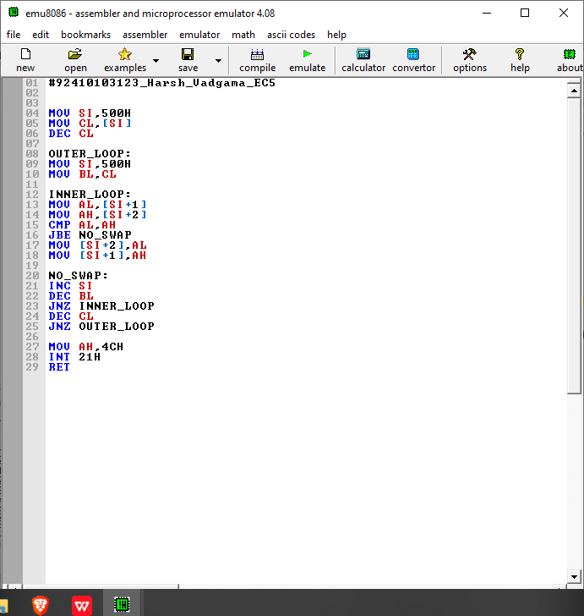

**Emulate the code and provide the data in memory:**

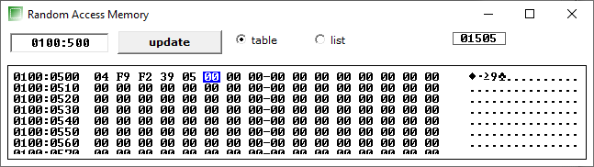

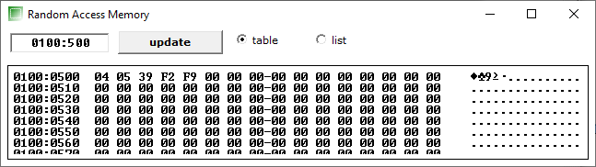

**Final output after data stored in ascending order:**

**Homework:**

**Write a program in 8086 microprocessor to sort numbers in descending order in an array of n numbers, where size “n” is stored at memory address 0100 : 500 and the numbers are stored from memory address 0100 : 501.**

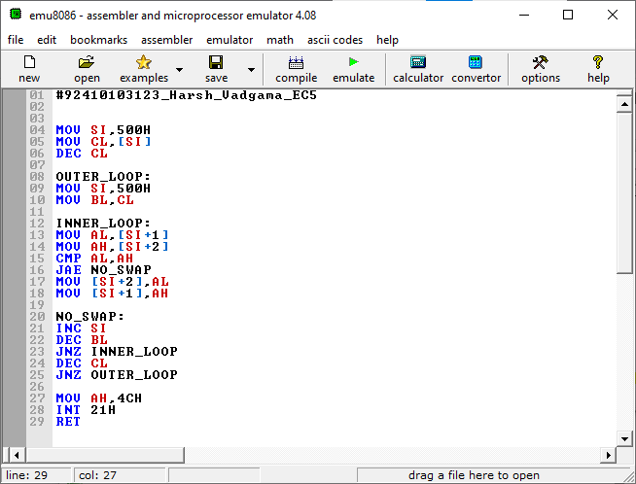

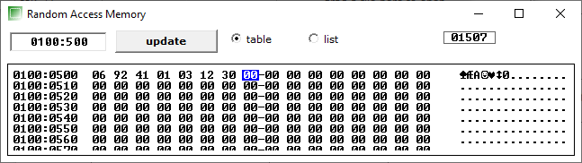

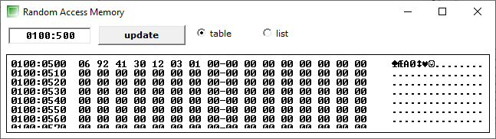

**Conclusion:**